**Class:** Final Year (Computer Science and Engineering)

**Year:** 2022-23 **Semester:** 1

**Course:** High Performance Computing Lab

**Practical No. 6**

**Exam Seat No: 2019BTECS00037**

**Title of practical: Study of MPI**

**Problem Statement 1: Implement a MPI program to give an example of Deadlock.**

*#include <mpi.h>*

*#include <stdio.h>*

*int main(int argc, char **argv)*

*{*

*int rank;*

*int num;*

*MPI_Init(&argc, &argv);*

*MPI_Comm_size(MPI_COMM_WORLD, &num);*

*MPI_Comm_rank(MPI_COMM_WORLD, &rank);*

*MPI_Status status;*

*double d = 483048.0;*

*int tag = 1;*

*//calculating next rank*

*int rank_next = (rank + 1) % num;*

*//prev process rank*

*int rank_prev = rank == 0 ? num - 1 : rank - 1;*

*if (num % 2 == 0)*

*{*

*printf("Rank %d: sending to %d\n", rank, rank_next);*

*MPI_Send(&d, 1, MPI_DOUBLE, rank_next, tag, MPI_COMM_WORLD);*

*printf("Rank %d: receiving from %d\n", rank, rank_prev);*

*MPI_Recv(&d, 1, MPI_DOUBLE, rank_prev, tag, MPI_COMM_WORLD, &status);*

*}*

*else*

*{*

*printf("Rank %d: receiving from %d\n", rank, rank_prev);*

*MPI_Recv(&d, 1, MPI_DOUBLE, rank_prev, tag, MPI_COMM_WORLD, &status);*

*printf("Rank %d: sending to %d\n", rank, rank_next);*

*MPI_Send(&d, 1, MPI_DOUBLE, rank_next, tag, MPI_COMM_WORLD);*

*}*

*MPI_Finalize();*

*return 0;*

*}*

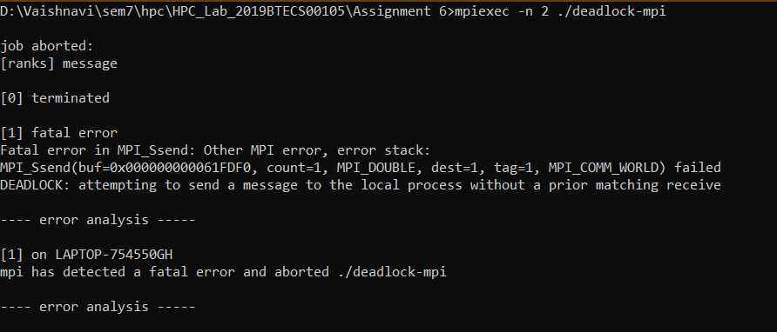

**Problem Statement 2: Implement blocking MPI send & receive to demonstrate Nearest neighbor exchange of data in a ring topology**

*#include <mpi.h>*

*#include <stdio.h>*

*int main(int argc, char **argv)*

*{*

*int rank;*

*int num;*

*MPI_Init(&argc, &argv);*

*MPI_Comm_size(MPI_COMM_WORLD, &num);*

*MPI_Comm_rank(MPI_COMM_WORLD, &rank);*

*MPI_Status status;*

*double d = 483048.0;*

*int tag = 1;*

*//calculating next rank*

*int rank_next = (rank + 1) % num;*

*//prev process rank*

*int rank_prev = rank == 0 ? num - 1 : rank - 1;*

*if (num % 2 == 0)*

*{*

*printf("Rank %d: sending to %d\n", rank, rank_next);*

*MPI_Send(&d, 1, MPI_DOUBLE, rank_next, tag, MPI_COMM_WORLD);*

*printf("Rank %d: receiving from %d\n", rank, rank_prev);*

*MPI_Recv(&d, 1, MPI_DOUBLE, rank_prev, tag, MPI_COMM_WORLD, &status);*

*}*

*else*

*{*

*printf("Rank %d: receiving from %d\n", rank, rank_prev);*

*MPI_Recv(&d, 1, MPI_DOUBLE, rank_prev, tag, MPI_COMM_WORLD, &status);*

*printf("Rank %d: sending to %d\n", rank, rank_next);*

*MPI_Send(&d, 1, MPI_DOUBLE, rank_next, tag, MPI_COMM_WORLD);*

*}*

*MPI_Finalize();*

*return 0;*

*}*

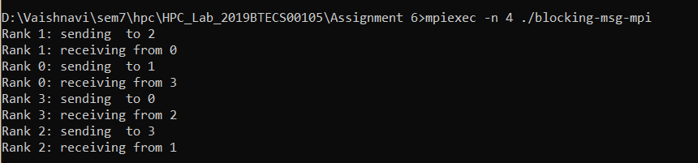

**Problem Statement 3: Write a MPI program to find the sum of all the elements of an array A of size n. Elements of an array can be divided into two equals groups. The first [n/2] elements are added by the first process, P0, and last [n/2] elements the by second process, P1. The two sums then are added to get the final result.**

*#include <mpi.h>*

*#include <stdio.h>*

*#define localSize 1000*

*int local[1000]; // to store the subarray data comming from process 0;*

*int main(int argc, char **argv)*

*{*

*int rank;*

*int num;*

*int n = 10;*

*int arr[10] = {1, 2, 3, 4, 5, 6, 7, 8, 9, 10};*

*int per_process, elements_received;*

*MPI_Init(&argc, &argv);*

*MPI_Comm_size(MPI_COMM_WORLD, &num);*

*MPI_Comm_rank(MPI_COMM_WORLD, &rank);*

*MPI_Status status;*

*// process with rank 0 will divide data among all processes and add partial sums to get final sum*

*if (rank == 0)*

*{*

*int index, i;*

*per_process = n / num;*

*if (num > 1) // if more than 1 processes available*

*{*

*//divide array data among processes*

*for (i = 1; i < num - 1; i++)*

*{*

*//calculating first index of subarray that need to be send to ith process*

*index = i * per_process;*

*//send no of elements and subarray of that lenght to each process*

*MPI_Send(&per_process, 1, MPI_INT, i, 0, MPI_COMM_WORLD);*

*MPI_Send(&arr[index], per_process, MPI_INT, i, 0, MPI_COMM_WORLD);*

*}*

*// for last process send all remaining elements*

*index = i * per_process;*

*int ele_left = n - index;*

*MPI_Send(&ele_left, 1, MPI_INT, i, 0, MPI_COMM_WORLD);*

*MPI_Send(&arr[index], ele_left, MPI_INT, i, 0, MPI_COMM_WORLD);*

*}*

*// add numbers on process with rank 0*

*int sum = 0;*

*for (int i = 0; i < per_process; i++)*

*{*

*sum += arr[i];*

*}*

*// add all partial sums from all processes*

*int tmp;*

*for (int i = 1; i < num; i++)*

*{*

*MPI_Recv(&tmp, 1, MPI_INT, MPI_ANY_SOURCE, 0, MPI_COMM_WORLD, &status);*

*int sender = status.MPI_SOURCE;*

*sum += tmp;*

*}*

*printf("Sum of array = %d\n", sum);*

*}*

*else // if rank of process is not 0, then receive elements and calculate partial sums*

*{*

*// receive no of elements and elements form process 0 and store them on local array*

*MPI_Recv(&elements_received, 1, MPI_INT, 0, 0, MPI_COMM_WORLD, &status);*

*MPI_Recv(&local, elements_received, MPI_INT, 0, 0, MPI_COMM_WORLD, &status);*

*// calculate partial local sum*

*int partial_sum = 0;*

*for (int i = 0; i < elements_received; i++)*

*{*

*partial_sum += local[i];*

*}*

*//send calculated partial sum to process with rank 0*

*MPI_Send(&partial_sum, 1, MPI_INT, 0, 0, MPI_COMM_WORLD);*

*}*

*MPI_Finalize();*

*return 0;*

*}*

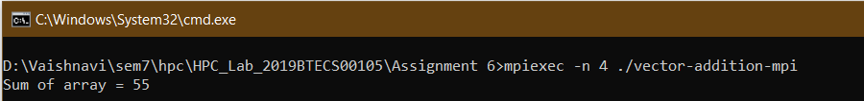

**Github Link:**

[**https://github.com/OnkarGavali/HPC_Lab/tree/main/Practical_No6**](https://github.com/OnkarGavali/HPC_Lab/tree/main/Practical_No6)